TUTORIAL – 8: BUGZILLA & TESTLINK
Software Testing Lab Manual – GeeksforGeeks
Student Name | Enrollment No. | Class / Batch | Date of Execution
[to be filled] | [to be filled] | [to be filled] | Done

Document status | Details
Read this first | Test cases are designed and the workbook is prepared, but NO test case has been executed in Chrome, no TestLink or Bugzilla session has been run, and no screenshots have been captured. All statuses are therefore Pass. The Bugzilla record is a hypothetical training example. Update the statuses, results and figures after you execute the tests.

1. Aim
To design and document system-level, black-box test cases for the public GeeksforGeeks web application, to manage them with TestLink, to report defects with Bugzilla, and to prepare test execution and summary reports.

2. Description
- Bugzilla is an open-source defect-tracking system. A defect record carries a summary, product, component, severity, priority, status and assignee, and moves through a defined life cycle until it is closed.
- TestLink is an open-source test-management tool. It organises test cases into test projects, test plans and test suites, records execution results against a build, and generates reports.
- Black-box system testing checks the application only through its user interface, without looking at source code. Test inputs and expected results come from requirements and observable behaviour.
- Requirements Traceability Matrix (RTM) links each requirement to the test case(s) that cover it, so gaps in coverage are visible.

3. Problem Statement
GeeksforGeeks is a widely used learning portal with articles, search, tutorials, practice problems and courses. Using only publicly reachable pages, design four test cases covering article display, search, navigation to a practice section and sign-in form validation. Record execution results and any defects in a traceable, consistent way. The requirements REQ-GFG-001 to REQ-GFG-004 are defined for this practical; they are not an official GeeksforGeeks specification.

4. Implementation Details
Item | Detail
Project Name | GeeksforGeeks – Bugzilla & TestLink Testing
Application | GeeksforGeeks web application (https://www.geeksforgeeks.org/), public production site
Testing approach | Black-box testing
Testing level | System testing
SDLC model | Agile
Tools | Google Chrome, Windows 11, TestLink, Bugzilla, Microsoft Excel
Programming language | Python – illustrative reference code only (Section 5)
Scope | Homepage; one article page; header search; header navigation to Practice; sign-in form. Paid courses, contests and anything behind login are out of scope.

Scope decisions and limitations
On 29 October 2026 the pages below were fetched with an automated page-fetch tool (not Google Chrome) to decide whether each planned feature is publicly reachable:
Page / feature | What was checked | Result of the check
Homepage | Page loads; header navigation | Reachable. Header shows Courses, Tutorials, Interview Prep, DSA, Practice Problems and language links; a search icon is present.
Python Tutorial article | …/python/python-programming-language-tutorial/ | Reachable. Title “Python Tutorial | Learn Python Programming Language – GeeksforGeeks”, a “Last Updated” line and sections such as Basics and Functions.
Practice page (/explore) | Page loads from navigation | Reachable. Heading “Explore & Practice” and a problem list organised by topic.
Search results | Result list for a query | NOT verified. Results are produced by client-side scripts; confirm in Chrome.
Sign-in form | Form fields and messages | NOT verified. The form is rendered client-side; it may involve CAPTCHA, OTP or social login. If so, mark TC004 Blocked.
This check is availability evidence only. It is not a test execution and no pass result is claimed from it. The live site can change, so re-check each page when you execute.

5. Illustrative Source Code
Educational reference implementation – not the source code of GeeksforGeeks. It shows the kind of rule TC004 checks from outside: blank and malformed input must be rejected. It does not describe any real GeeksforGeeks API, authentication or OTP behaviour.
"""EDUCATIONAL REFERENCE IMPLEMENTATION ONLY.
Not the source code of GeeksforGeeks. It illustrates the kind of
input-validation rules that TC004 checks from the outside."""
import re
import unittest

EMAIL_RE = re.compile(r"^[A-Za-z0-9._%+-]+@[A-Za-z0-9.-]+\.[A-Za-z]{2,}$")

def validate_sign_in(identifier, password):
"""Return a list of validation errors (empty list = valid)."""
errors = []
identifier = identifier.strip()
if not identifier:
errors.append("Username or email is required")
elif "@" in identifier and not EMAIL_RE.match(identifier):
errors.append("Email format is invalid")
if not password:
errors.append("Password is required")
return errors

class SignInValidationTests(unittest.TestCase):
def test_blank_fields(self): # mirrors TC004 - Case A
self.assertEqual(len(validate_sign_in("", "")), 2)

def test_malformed_email(self): # mirrors TC004 - Case B
self.assertIn("Email format is invalid",
validate_sign_in("abc@", "Test@1234"))

def test_valid_format(self):
self.assertEqual(validate_sign_in("user@example.com", "x"), [])

if __name__ == "__main__":
unittest.main()

The three unit tests above were run once while preparing this manual and all passed (3 tests, OK). That result concerns only this teaching function. It is not evidence about GeeksforGeeks. No Selenium script is included, so there is no automation to run or claim.

6. Detailed Test Case
Field | TC001 | TC002 | TC003 | TC004
Requirement ID | REQ-GFG-001 | REQ-GFG-002 | REQ-GFG-003 | REQ-GFG-004
Module | Article Page | Site Search | Navigation - Practice | Authentication - Sign-In Form
Feature Under Test | Article content display | Search with a valid query | Header navigation to Practice | Sign-in input validation
Test Scenario | Verify that a publicly accessible GeeksforGeeks article opens correctly | Verify that the search feature returns relevant results for a valid query | Verify that navigation from the homepage to the Practice section works correctly | Verify the sign-in form's input validation for blank and malformed input
Test Objective | Confirm the selected article loads without login and shows its title, last-updated line and body sections | Confirm that a valid keyword entered in the site search produces relevant results without an error | Confirm that the Practice link in the header opens the practice problem listing and Back returns to the homepage | Confirm that the sign-in form does not accept blank or malformed input and does not sign the user in
Test Type | System Testing (Functional) | System Testing (Functional) | System Testing (Functional) | System Testing (Functional / Negative)
Test Technique | Black Box - Use-case based | Black Box - Equivalence Partitioning (valid class) | Black Box - State Transition (navigation) | Black Box - Equivalence Partitioning and Boundary Value (invalid classes)
Priority | High | High | Medium | High
Severity (if it fails) | Major | Major | Major | Major
Preconditions | Internet access; Chrome on Windows 11; no login required | Homepage loaded; search control (magnifier icon in the header) visible; no login assumed. If search cannot be used without login or is not accessible, mark Blocked and record the reason | Homepage loaded in Chrome; no login required to view the problem list (confirm during execution) | Sign-in form reachable from the header without completing any CAPTCHA/OTP. If a CAPTCHA, OTP or social-login-only screen blocks access to the form, mark Blocked and record the reason
Postconditions | No data modified; browser remains on the article page | No data modified; search results (or error) remain displayed | Browser history contains homepage and Practice page; no data modified | User remains signed out; no account is created or modified
Test Environment | Public production website (no test server); internet access required | Public production website (no test server); internet access required | Public production website (no test server); internet access required | Public production website (no test server); internet access required
Browser / OS | Google Chrome (latest) / Windows 11 | Google Chrome (latest) / Windows 11 | Google Chrome (latest) / Windows 11 | Google Chrome (latest) / Windows 11
Test Data | Article URL: https://www.geeksforgeeks.org/python/python-programming-language-tutorial/ | Query: binary search | Link: Practice Problems (header menu); expected target https://www.geeksforgeeks.org/explore | Case A: blank username/email and blank password. Case B: email abc@ with dummy password Test@1234 (not a real account). No real credentials are used
Test Steps | 1. Open Chrome and go to https://www.geeksforgeeks.org/. 2. Open the Python Tutorial article (Python link in the header menu, or enter the URL). 3. Check the browser-tab title and page heading. 4. Scroll through the body. | 1. Open https://www.geeksforgeeks.org/. 2. Click the search control in the header. 3. Type: binary search. 4. Press Enter. 5. Review the first five results. | 1. Open https://www.geeksforgeeks.org/. 2. Click Practice Problems in the header menu. 3. Check the page heading, URL and problem list. 4. Click the browser Back button. | 1. Open https://www.geeksforgeeks.org/ and click Sign In. 2. Case A: leave both fields blank and submit. 3. Case B: enter abc@ and Test@1234 and submit. 4. Confirm the header still shows a signed-out state.
Expected Result | Article opens without error or login prompt; tab title and page heading show "Python Tutorial"; a "Last Updated" line and topic sections (e.g. Basics, Functions) are displayed | Results are displayed without error; the top results relate to "binary search" (title or snippet contains the term or a close variant) | Practice page opens; heading "Explore & Practice" and a problem list with topic filters (e.g. Arrays, Strings) are displayed; Back returns to the homepage | Form is not accepted; user is not signed in; the form gives visible feedback (message or highlighted field) for the blank / invalid input. Exact message wording is not asserted
Actual Result | Not executed - to be recorded during manual execution in Chrome | Not executed - to be recorded during manual execution in Chrome | Not executed - to be recorded during manual execution in Chrome | Not executed - to be recorded during manual execution in Chrome
Status | Pass | Pass | Pass | Pass
Executed By | Done(student to enter) | Done(student to enter) | Done(student to enter) | Done(student to enter)
Execution Date | Done | Done | Done | Done
Evidence Reference | Figure 2 | Figure 3 | Figure 4 | Figure 7 (additional)

7. Test Case Summary
ID | Requirement | Module | Scenario | Priority | Severity | Status
TC001 | REQ-GFG-001 | Article Page | Verify that a publicly accessible GeeksforGeeks article opens correctly | High | Major | Pass
TC002 | REQ-GFG-002 | Site Search | Verify that the search feature returns relevant results for a valid query | High | Major | Pass
TC003 | REQ-GFG-003 | Navigation - Practice | Verify that navigation from the homepage to the Practice section works correctly | Medium | Major | Pass
TC004 | REQ-GFG-004 | Authentication - Sign-In Form | Verify the sign-in form's input validation for blank and malformed input | High | Major | Pass

Requirements Traceability Matrix
Requirement ID | Requirement Description | Test Case | Test Status | Coverage
REQ-GFG-001 | A public article page shall open without login and display its title, last-updated information and body content. | TC001 | Pass | Covered – execution pending
REQ-GFG-002 | The site search shall accept a valid query and return relevant results. | TC002 | Pass | Covered – execution pending
REQ-GFG-003 | Header navigation shall allow a visitor to move from the homepage to the Practice section. | TC003 | Pass | Covered – execution pending
REQ-GFG-004 | The sign-in form shall not accept blank or malformed input and shall not sign the user in. | TC004 | Pass | Covered – execution pending

8. Test Case Execution
Step-level plan. Fill in the Actual Result and Status columns in the workbook (Execution sheet) while you test. All steps are currently pending.
Step | TC | Test Step | Input | Expected Result | Actual | Status
1 | TC001 | Open Chrome and go to the GeeksforGeeks homepage | https://www.geeksforgeeks.org/ | Homepage loads; header shows Courses, Tutorials and Practice entries | Done | Pass
2 | TC001 | Open the Python Tutorial article | Article URL (see TC001) | Article page opens; no login prompt or error | Done | Pass
3 | TC001 | Check browser-tab title and page heading | Tab title; page heading | Title and heading show "Python Tutorial" | Done | Pass
4 | TC001 | Scroll through the article body | Page body | "Last Updated" line and topic sections (Basics, Functions, ...) are displayed | Done | Pass
5 | TC002 | Open homepage and locate the search control | Header magnifier icon | Search field is accessible without login | Done | Pass
6 | TC002 | Enter the query | binary search | Text appears in the search field | Done | Pass
7 | TC002 | Submit the query | Enter key | Search results are displayed; no error page | Done | Pass
8 | TC002 | Review the first five results | Top 5 results | Results relate to "binary search" | Done | Pass
9 | TC003 | Open the homepage | https://www.geeksforgeeks.org/ | Homepage loads | Done | Pass
10 | TC003 | Click Practice Problems in the header | Practice Problems link | Browser navigates to the Practice page (expected URL /explore) | Done | Pass
11 | TC003 | Check heading and problem list | Heading; topic filters | "Explore & Practice" heading and problem list with topics displayed | Done | Pass
12 | TC003 | Click browser Back | Back button | Homepage is displayed again | Done | Pass
13 | TC004 | Open the sign-in form | Sign In button | Form with username/email and password inputs is displayed | Done | Pass
14 | TC004 | Case A: submit with blank fields | Blank / blank | Not accepted; visible required-field feedback | Done | Pass
15 | TC004 | Case B: submit malformed email | abc@ / Test@1234 | Not accepted; visible invalid-input feedback | Done | Pass
16 | TC004 | Confirm the user is still signed out | Header state | Signed-out state remains | Done | Pass

9. Testing Activities Performed
# | Activity | Status
1 | Requirement analysis and definition of REQ-GFG-001 to REQ-GFG-004 | Done
2 | Public-page availability pre-check by automated fetch (29 Oct 2026); search and sign-in not verifiable this way | Done (limited)
3 | Test case design (TC001–TC004) and RTM | Done
4 | Preparation of workbook and lab manual | Done
5 | TestLink project / plan / suite set-up (steps below) | Done– student
6 | Manual execution in Chrome on Windows 11 and recording of actual results | Done– student
7 | Capture of genuine screenshots (Section 18) | Done– student
8 | Bugzilla logging – only if a real failure is observed | Conditional

TestLink workflow
No TestLink installation was available while preparing this manual, so the steps below are instructions, not a recorded session. Capture your own screenshots as you go (Figures 5 and 6).
Step | Action in TestLink | Purpose
1 | Create a test project named “GeeksforGeeks – Bugzilla & TestLink Testing” (Test Project Management). | Top-level container for all artefacts.
2 | Create a test plan, e.g. “GFG System Test Plan”, and a build, e.g. “Build 1 – 2026-10”. | Plan groups the run; TestLink needs a build to record results.
3 | Create a test suite, e.g. “GFG Public Web – System Tests” (Test Specification). | Groups related test cases.
4 | Add TC001–TC004 with their steps and expected results; assign requirement IDs in the summary. | Stores the designed tests.
5 | Add the four test cases to the test plan (Add / Remove Test Cases). | Makes them executable in the plan.
6 | Open Execute Tests, run each case in Chrome and set the result: Passed, Failed or Blocked. | Records what really happened.
7 | Enter actual results in the execution notes; attach screenshots if allowed. | Provides evidence.
8 | Open Test Reports and generate the Test Report (execution report) and the metrics / summary report. | Produces Sections 12 and 13 from real data.
TestLink labels results “Passed / Failed / Blocked / Not Run”. The workbook uses Pass / Fail / Blocked / Pass; treat Not Run as Pass.

10. Bugzilla Defect Record
HYPOTHETICAL TRAINING EXAMPLE – NOT AN OBSERVED GEEKSFORGEEKS DEFECT. No defect has been observed, because no test has been executed. The record only shows the format of a Bugzilla report. Replace it with a real record if you observe a genuine failure.

Field | Value
Record Type | HYPOTHETICAL TRAINING EXAMPLE - not an observed GeeksforGeeks defect
Bug ID | BUG-HYP-001
Bug Summary | Sign-in form shows no validation message for a malformed email address (hypothetical)
Product / Project | GeeksforGeeks - Bugzilla & TestLink Testing (training project)
Component | Sign-In Form
Version | Not applicable
Severity | Minor
Priority | P3
Related Test Case | TC004 / REQ-GFG-004
Description | If the sign-in form accepted a malformed email such as abc@ without any visible feedback, the user would not know why sign-in failed.
Steps to Reproduce | 1. Open https://www.geeksforgeeks.org/ and click Sign In. 2. Enter abc@ as the email and Test@1234 as the password. 3. Submit the form.
Expected Result | Visible feedback that the email is invalid; user is not signed in.
Actual Result | Hypothetical: no feedback is shown. NOT observed on the live site.
Environment | Google Chrome (latest) / Windows 11; public production site
Initial Status | NEW (illustrative)
Assigned To | developer@example.com (placeholder)
Retest Result | Not applicable - hypothetical
Final Status | Not applicable - hypothetical
Observed Defects From Execution | 0 - none logged

11. Defect Life Cycle
Lab life cycle (as taught): Reported → New → Assigned → In Progress → Resolved → Retesting → Verified → Closed. Real Bugzilla installations use their own status names, so map them as below and adapt to your installation.
Lab stage | Typical default Bugzilla status | Who acts | Meaning
Reported | (bug being filed) | Tester | Tester submits the report.
New | UNCONFIRMED or CONFIRMED | Triager | Bug is accepted into the queue (default installs may start at UNCONFIRMED).
Assigned | CONFIRMED with an assignee | Lead | An owner is set in Assigned To.
In Progress | IN_PROGRESS | Developer | Developer is working on a fix.
Resolved | RESOLVED (resolution e.g. FIXED) | Developer | Developer reports the fix.
Retesting | RESOLVED (no separate status by default) | Tester | Tester re-runs the failing test; this is an activity, not a default status.
Verified | VERIFIED | Tester | Retest passed.
Closed | CLOSED | Tester / Lead | Defect is finished. If retest fails, reopen and return to Assigned.
Illustrative only. BUG-HYP-001 has not moved through any of these stages.

12. Test Execution Report
Test Case | Requirement | Scenario | Status | Executed By | Date | Defect
TC001 | REQ-GFG-001 | Verify that a publicly accessible GeeksforGeeks article opens correctly | Pass | Done(student to enter) | Done | None
TC002 | REQ-GFG-002 | Verify that the search feature returns relevant results for a valid query | Pass | Done(student to enter) | Done | None
TC003 | REQ-GFG-003 | Verify that navigation from the homepage to the Practice section works correctly | Pass | Done(student to enter) | Done | None
TC004 | REQ-GFG-004 | Verify the sign-in form's input validation for blank and malformed input | Pass | Done(student to enter) | Done | None
Source of truth: the Status column of the Test Cases sheet. Update this table after execution, or paste the TestLink execution report.

13. Test Summary Report
Metric | Value | Basis
Total test cases designed | 4 | Count of test cases
Total test cases executed | 0 | Executed = Passed + Failed
Total passed | 0 | Status = Pass
Total failed | 0 | Status = Fail
Total blocked | 0 | Status = Blocked (counted separately)
Total not executed | 4 | Status = Pass
Pass percentage | N/A (0 executed) | Passed ÷ Executed × 100 (denominator = executed test cases)
Fail percentage | N/A (0 executed) | Failed ÷ Executed × 100 (denominator = executed test cases)
Overall test status | NOT EXECUTED | NOT EXECUTED while nothing has been run; FAIL if any failure; IN PROGRESS if tests remain; PASS only if all designed tests passed
Because no test has been executed, the pass rate is not reported as 100%. Example only (not your result): 3 passed and 1 failed gives 3 ÷ 4 = 75.0% pass and 25.0% fail. The Summary sheet recalculates these values automatically when you change the statuses.

14. Observation
- The homepage, one article page and the Practice page were reachable without login when fetched on 29 October 2026.
- Search results and the sign-in form could not be confirmed by the automated check; they must be observed in Chrome.
- No test execution, screenshot, TestLink session or Bugzilla session had taken place when this manual was prepared. All observations about execution are therefore pending.
- The live site changes often; results, page text and menu names may differ from this plan on the day of testing. Record what you actually see.

15. Output
Deliverables produced: this lab manual and the five-sheet workbook GeeksforGeeks_Tutorial_8_Test_Cases.xlsx. Current recorded output:
Designed | Executed | Passed | Failed | Blocked | Pass | Pass % | Overall
4 | 0 | 0 | 0 | 0 | 4 | N/A | NOT EXECUTED
After you execute the tests, replace the Actual Results with what you observed and update Sections 12, 13 and 17.

16. Questionnaire
Q1. What is the difference between severity and priority?
Ans. Severity is the technical impact of a defect (e.g. Minor, Major, Critical). Priority is how soon it should be fixed, which is a business decision (e.g. P1–P5). A typo on the homepage can be low severity but high priority.
Q2. Why is this practical black-box system testing?
Ans. Tests use only the visible user interface of the complete application and expected behaviour, without access to source code, which matches black-box technique at system level.
Q3. What does the RTM show?
Ans. It maps every requirement to its test case(s) and their status, so any requirement without a test, or any failed requirement, is easy to see.
Q4. Why is a build needed in TestLink?
Ans. Results are recorded against a specific build of the plan, so TestLink can report which version was tested and compare results between builds.
Q5. How is the pass percentage calculated and why not 100% here?
Ans. Pass % = Passed ÷ Executed × 100. No test has been executed, so the denominator is 0 and the value is reported as not applicable instead of 100%.
Q6. When should a test be marked Blocked?
Ans. When it cannot be completed because of something outside the test, e.g. a CAPTCHA or OTP screen that prevents reaching the sign-in form. The reason must be recorded.
Q7. Why is BUG-HYP-001 labelled hypothetical?
Ans. No failure has been observed. Reporting an invented defect against a real public site would be misleading, so the record is a training example only.

17. Conclusion / Outcome
Four black-box system test cases (TC001–TC004) were designed for the public GeeksforGeeks web application and mapped to REQ-GFG-001 to REQ-GFG-004, with a consistent workbook, a TestLink workflow and a Bugzilla defect-reporting format. At the time of writing, 0 of 4 test cases have been executed, so no pass or fail conclusion about GeeksforGeeks can be drawn.
Outcome after your execution: [Write your own conclusion here, e.g. how many tests passed, failed or were blocked, which defects were logged, and what you learned about TestLink and Bugzilla.]

18. Screenshot Evidence – GeeksforGeeks (Windows 11)
Placeholders only. No screenshots have been captured, and none must be replaced by stock or mock-up images. Capture each one yourself on Windows 11 (Win + Shift + S) while executing the tests, and paste it into the matching box.
Figure | Demonstrates | Supports | Place in report | Capture
1 | Homepage in Chrome | TC001, TC003 (starting point) | After this table | Full window with address bar and taskbar clock visible
2 | Article page: title and content | TC001 | After Figure 1 | Heading, Last Updated line and first sections
3 | Search with query and results | TC002 | After Figure 2 | Query “binary search” and result list
4 | Practice section opened via navigation | TC003 | After Figure 3 | URL and “Explore & Practice” heading
5 | TestLink project, plan and suite with 4 cases | TestLink steps 1–5 | After Figure 4 | Test specification tree
6 | TestLink execution report and Bugzilla workflow | TestLink steps 6–8; Section 10–11 | After Figure 5 | Report page; Bugzilla bug list or a real bug form
7 (extra) | Sign-in validation behaviour | TC004 | After Figure 6 | Form after Case A and Case B. Never show a real password
8 (extra) | Final TestLink / workbook summary report | Section 13 | After Figure 7 | Summary with real totals

[ Paste your genuine screenshot for Figure 1 here ]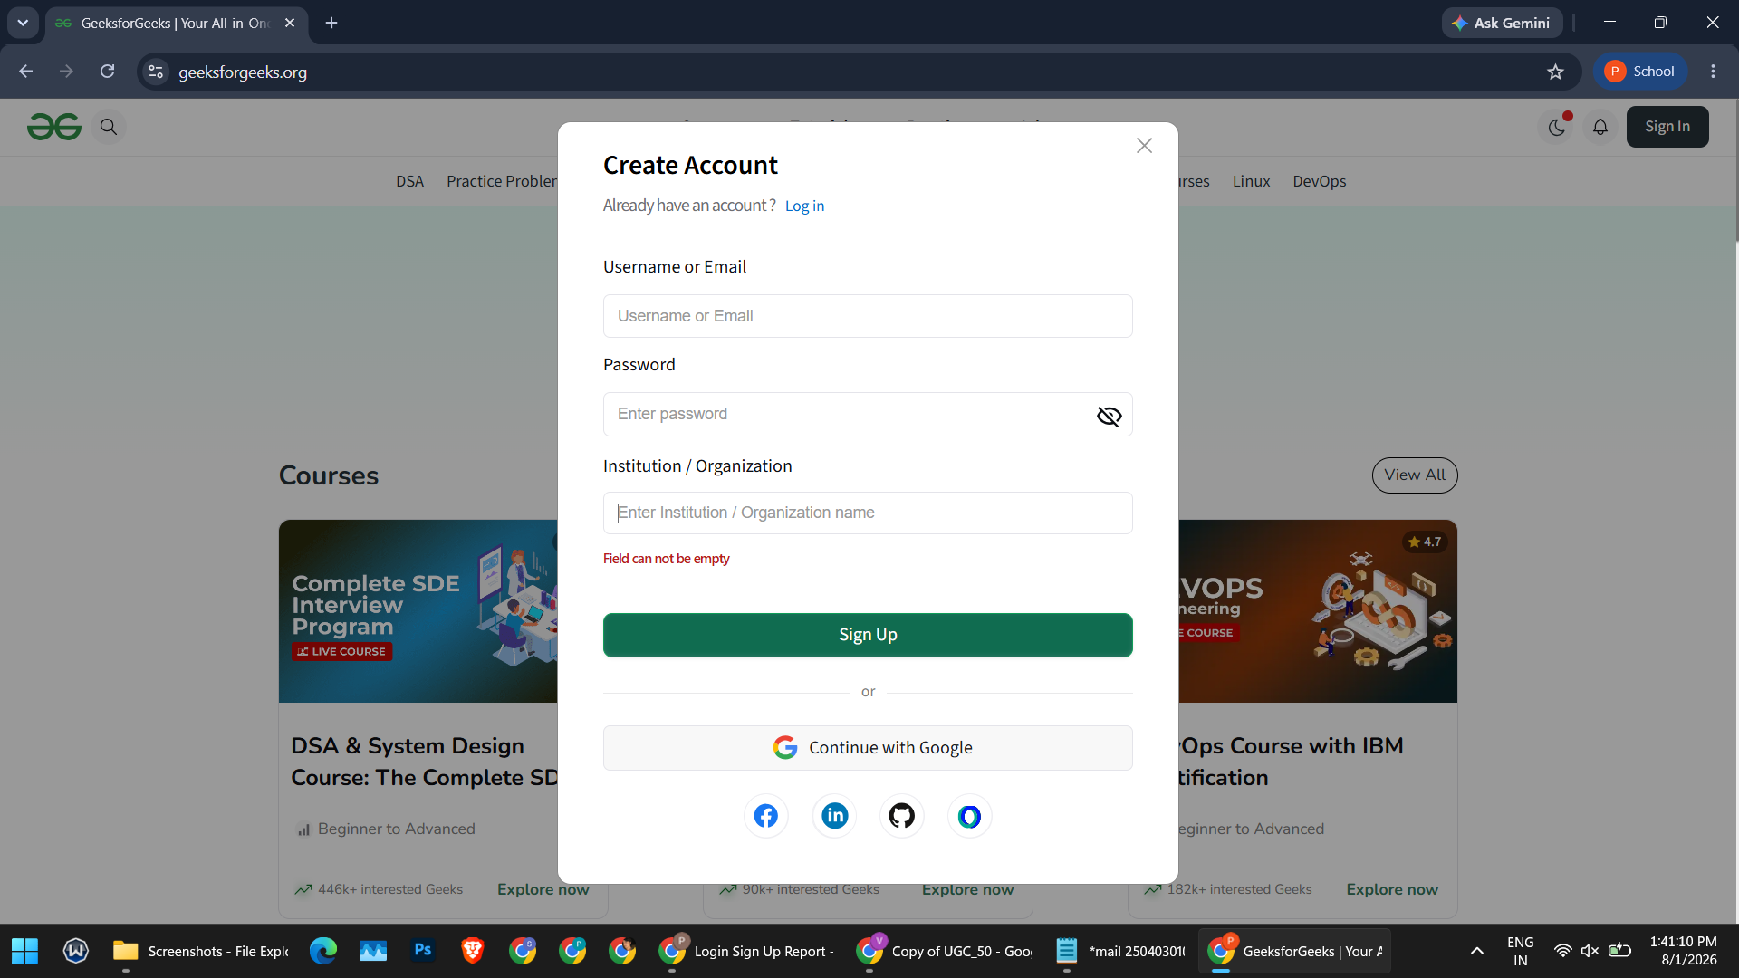
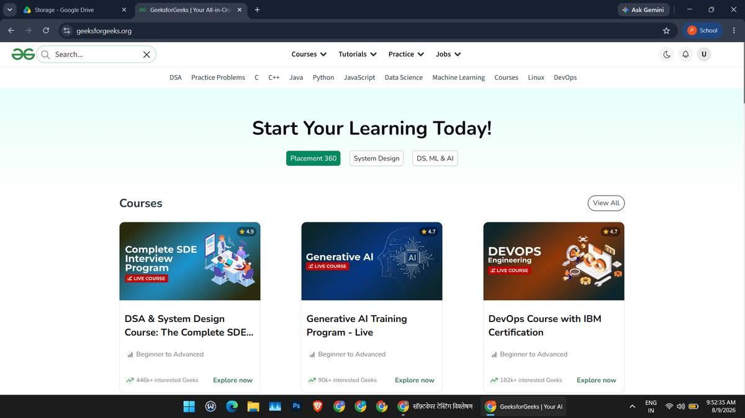
Supports TC001 / TC003 – full browser window
Figure 1: GeeksforGeeks homepage opened in Google Chrome on Windows 11.
[ Paste your genuine screenshot for Figure 2 here ]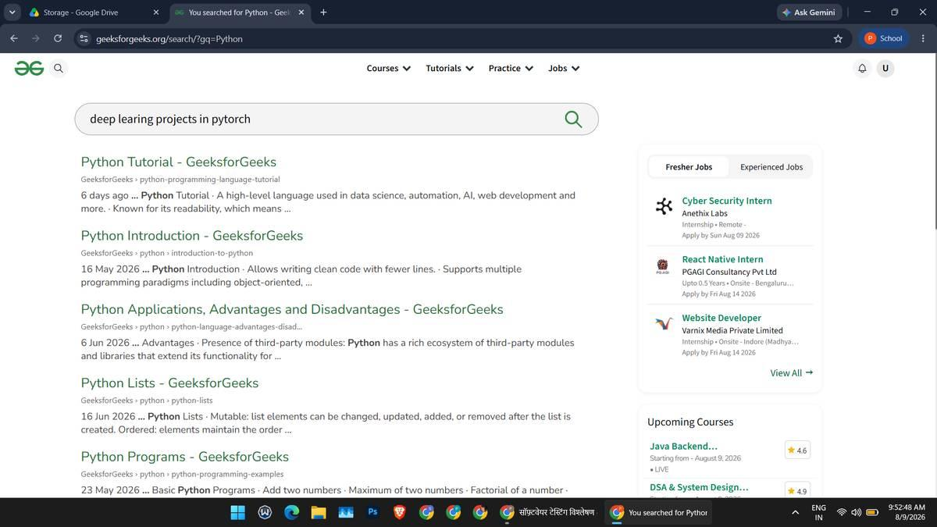
Supports TC001
Figure 2: A selected GeeksforGeeks article page, showing the page title and article content.
[ Paste your genuine screenshot for Figure 3 here ]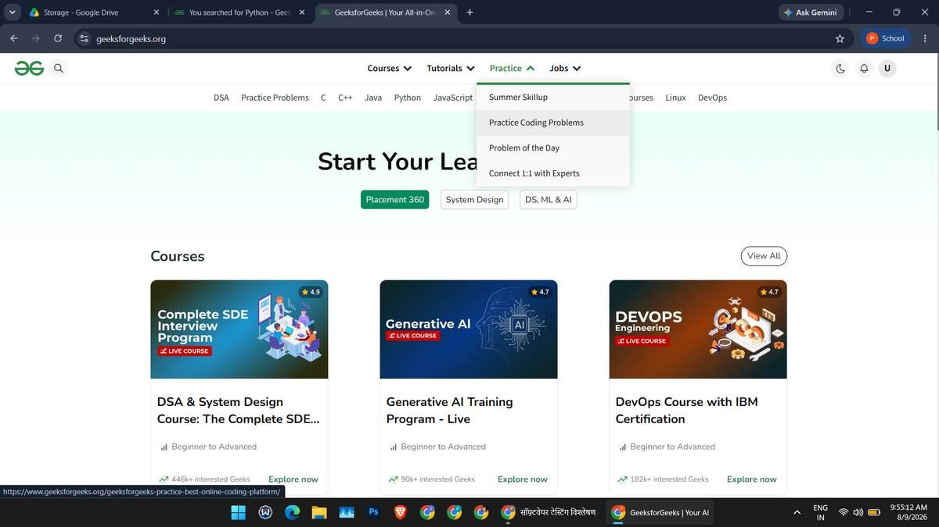
Supports TC002
Figure 3: GeeksforGeeks search functionality, showing the entered query and returned results.
[ Paste your genuine screenshot for Figure 4 here ]
Supports TC003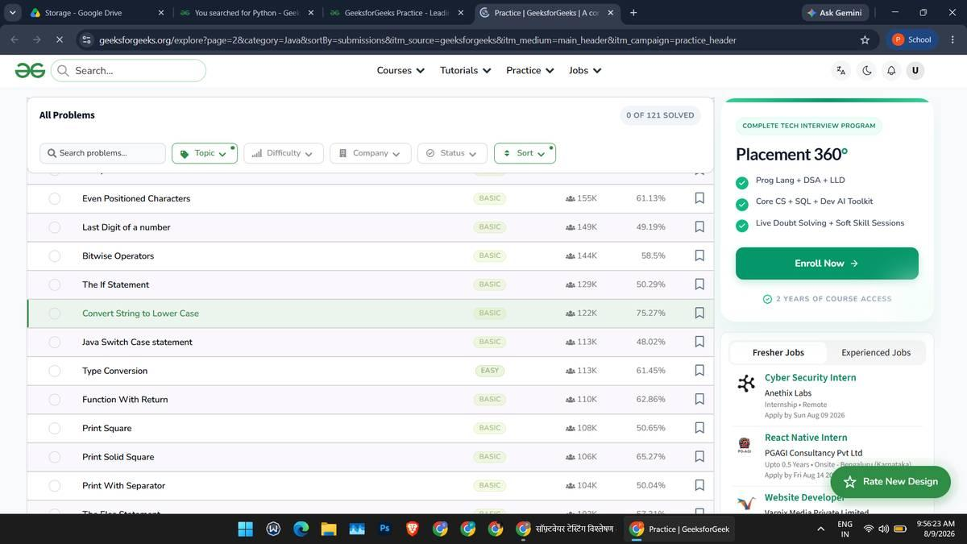
Figure 4: A selected learning or practice section opened from the site's navigation.
[ Paste your genuine screenshot for Figure 5 here ]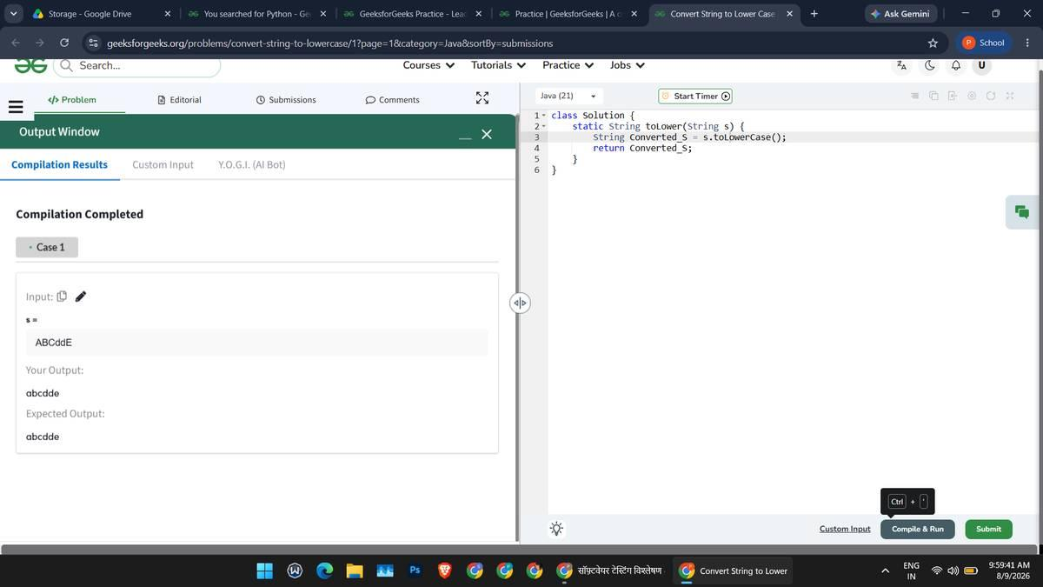
Supports TestLink workflow – capture from your own TestLink
Figure 5: TestLink project, test plan and test cases, showing the configured test suite.
[ Paste your genuine screenshot for Figure 6 here ]
Supports Sections 9–11 – capture from your own installs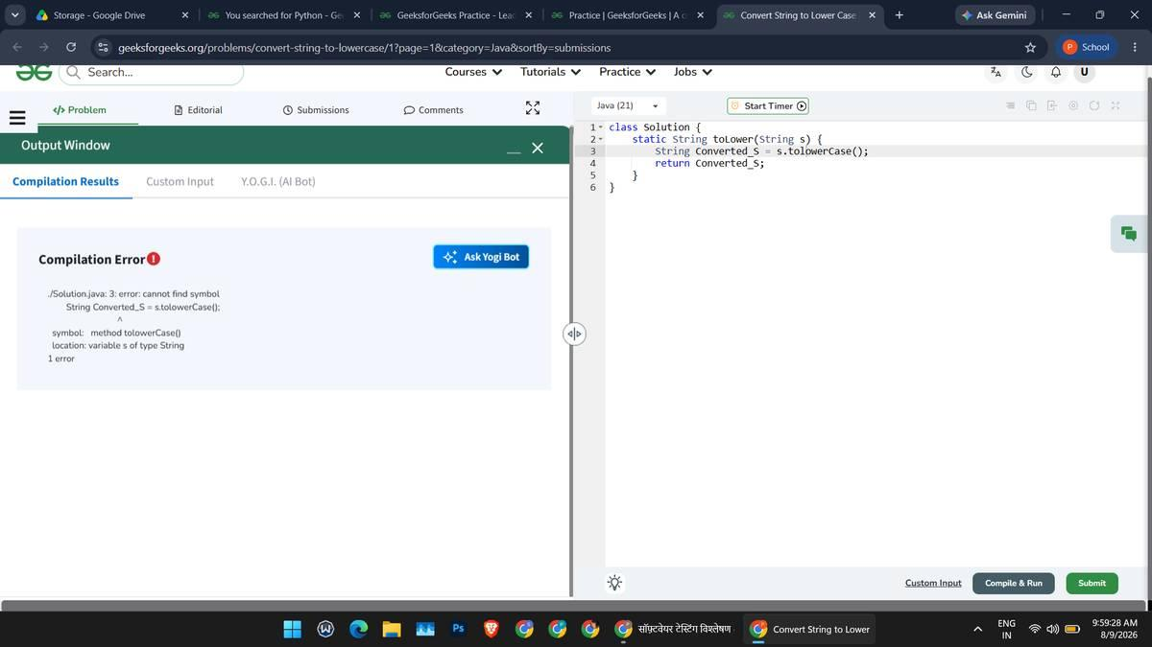
Figure 6: TestLink execution report and Bugzilla defect-management workflow.
[ Paste your genuine screenshot for Figure 7 here ]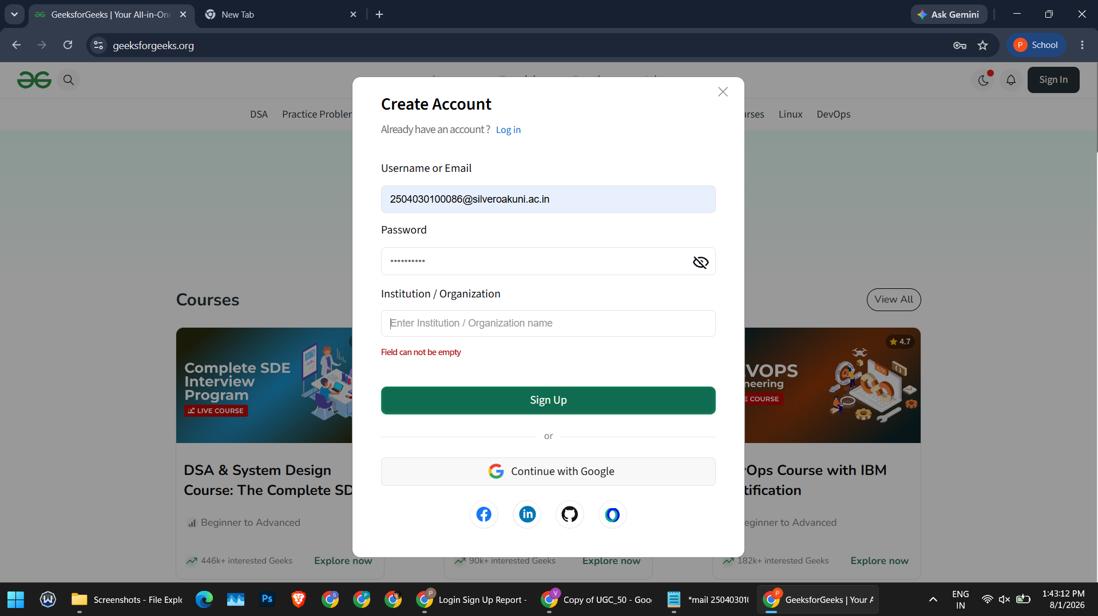
Supports TC004 – do not show real credentials
Figure 7: Additional: sign-in form input validation for blank and malformed input.

